Project 2: Detection of Eccentric Viewing in Low Vision Patients

Introduction
Central vision loss, often caused by conditions such as age-related macular degeneration (AMD), diabetic maculopathy, or hereditary retinal dystrophies, severely impacts a patient’s ability to read, recognize faces, and perform detailed visual tasks. To compensate, patients spontaneously develop eccentric fixation strategies by using a Preferred Retinal Locus (PRL) outside the damaged fovea. Identifying the PRL and training fixation stability are key aspects of low vision rehabilitation.
Currently, eccentric fixation evaluation is performed using microperimetry, which maps retinal sensitivity and fixation location. However, microperimetry devices are costly, require trained operators, and are often unavailable in community or resource-limited settings. Recent developments in computer vision and AI offer opportunities for accessible, video-based alternatives that can objectively detect eccentric viewing and assist in rehabilitation strategies.
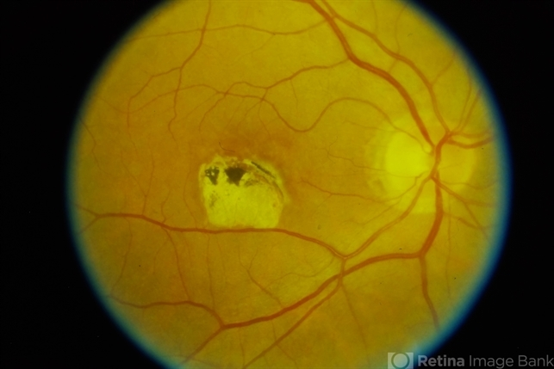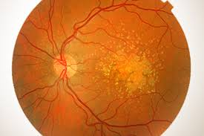

Need
- Affordable solution: Provides a low-cost alternative to expensive microperimetry.
- Accessibility: Can be implemented using standard digital devices (smartphones, tablets, or laptops).
- Clinical support: Helps low vision specialists objectively identify fixation strategies.
- Rehabilitation enhancement: Enables feedback-based training for improving fixation stability and functional vision outcomes.
- Scalability: Applicable in hospitals, vision rehabilitation centers, and even tele-rehabilitation setups.
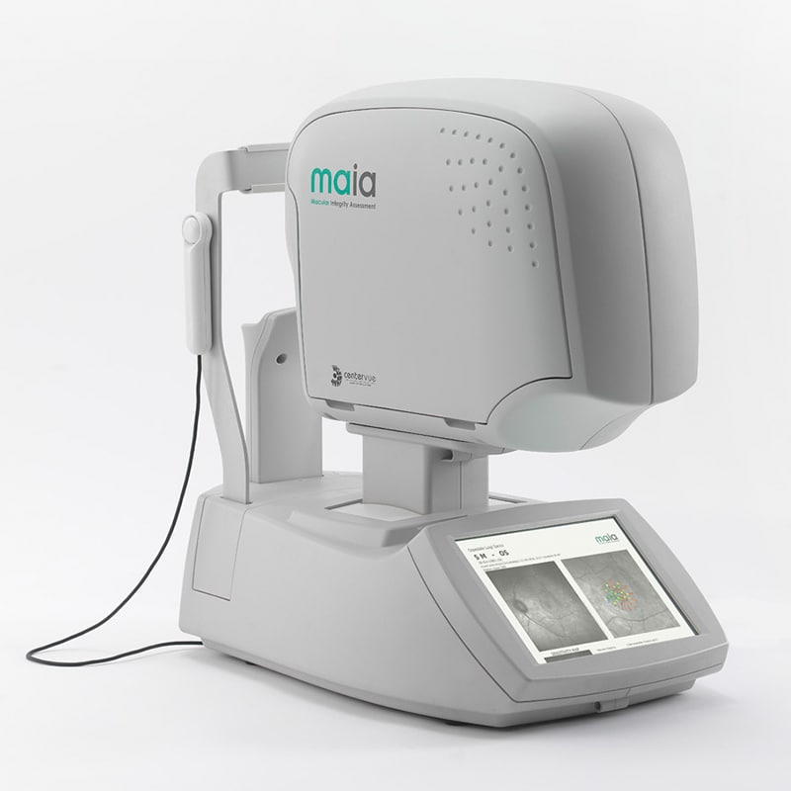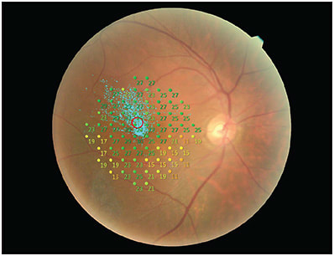

Hypothesis
An AI-based video analysis system can accurately detect eccentric fixation and identify the Preferred Retinal Locus (PRL) in low vision patients, providing comparable results to clinician-observed fixation strategies.

Review of Literature
- Timberlake et al. (1986): Documented eccentric fixation and PRL adaptation in patients with central vision loss.
- Liu et al. (2021): Explored VR-based PRL training systems but highlighted accessibility and cost barriers for widespread use.
- Current gap: No simple, video-based, AI-enabled clinical tool exists for eccentric fixation detection and rehabilitation support.

Materials and Methods

Study Design
Cross-sectional exploratory study with development and validation of an AI-based eccentric fixation detection tool.

Participants
- Inclusion criteria:
  - Diagnosed with central vision loss (e.g., AMD, macular dystrophy, diabetic maculopathy).
  - Best-corrected visual acuity between 6/18 – 6/60.
  - Cooperative and able to perform reading/visual tasks.
- Exclusion criteria:
  - Ocular motility disorders (strabismus, nystagmus).
  - Neurological impairments affecting eye movements.
  - Uncorrected significant refractive errors.

Materials
- Recording devices: High-resolution smartphone/tablet cameras or webcams (60 fps preferred).
- Stimuli:
  - Standardized reading passages (large and small print).
  - Optotype charts or fixation targets.
- Reference tool: Microperimetry (if available, for validation subset).
- Software:
  - Python ?-for gaze tracking.
  - AI frameworks - for PRL mapping.
  - Custom rehabilitation module for real-time visual feedback.

Procedure
- Video Data Collection
  - Record patients while performing reading tasks or fixating on a central target.
  - Simultaneously, clinicians note fixation behavior (e.g., eye movement pattern, stability).
- Data Preprocessing
  - Extract frames and annotate gaze direction, fixation points, and eye movements.
  - Normalize background and lighting.
- AI Model Development
  - Use gaze mapping algorithms to detect fixation points relative to target.
  - Identify PRL location (e.g., superior, inferior, nasal, temporal to fovea).
  - Assess fixation stability (dispersion of gaze points over time).
- Training Feedback Module
  - Integrate AI output into a visual training platform.
  - Provide real-time feedback to patients (e.g., “maintain fixation here”) for PRL training.
- Validation
  - Compare AI-detected PRL location with clinician assessment and microperimetry (where available).
  - Statistical measures:
    - Agreement: Cohen’s kappa or Bland–Altman analysis.
    - Reliability: Intraclass correlation coefficient (ICC).
    - Effectiveness: Pre–post analysis of fixation stability improvement with training module.

Expected Outcomes
- Development of an affordable and scalable AI tool for eccentric fixation detection.
- Accurate mapping of PRL location with high correlation to clinician or microperimeter findings.
- Integration of a feedback-based rehabilitation module for low vision patients.
- Potential for tele-rehabilitation applications in rural or underserved areas.

